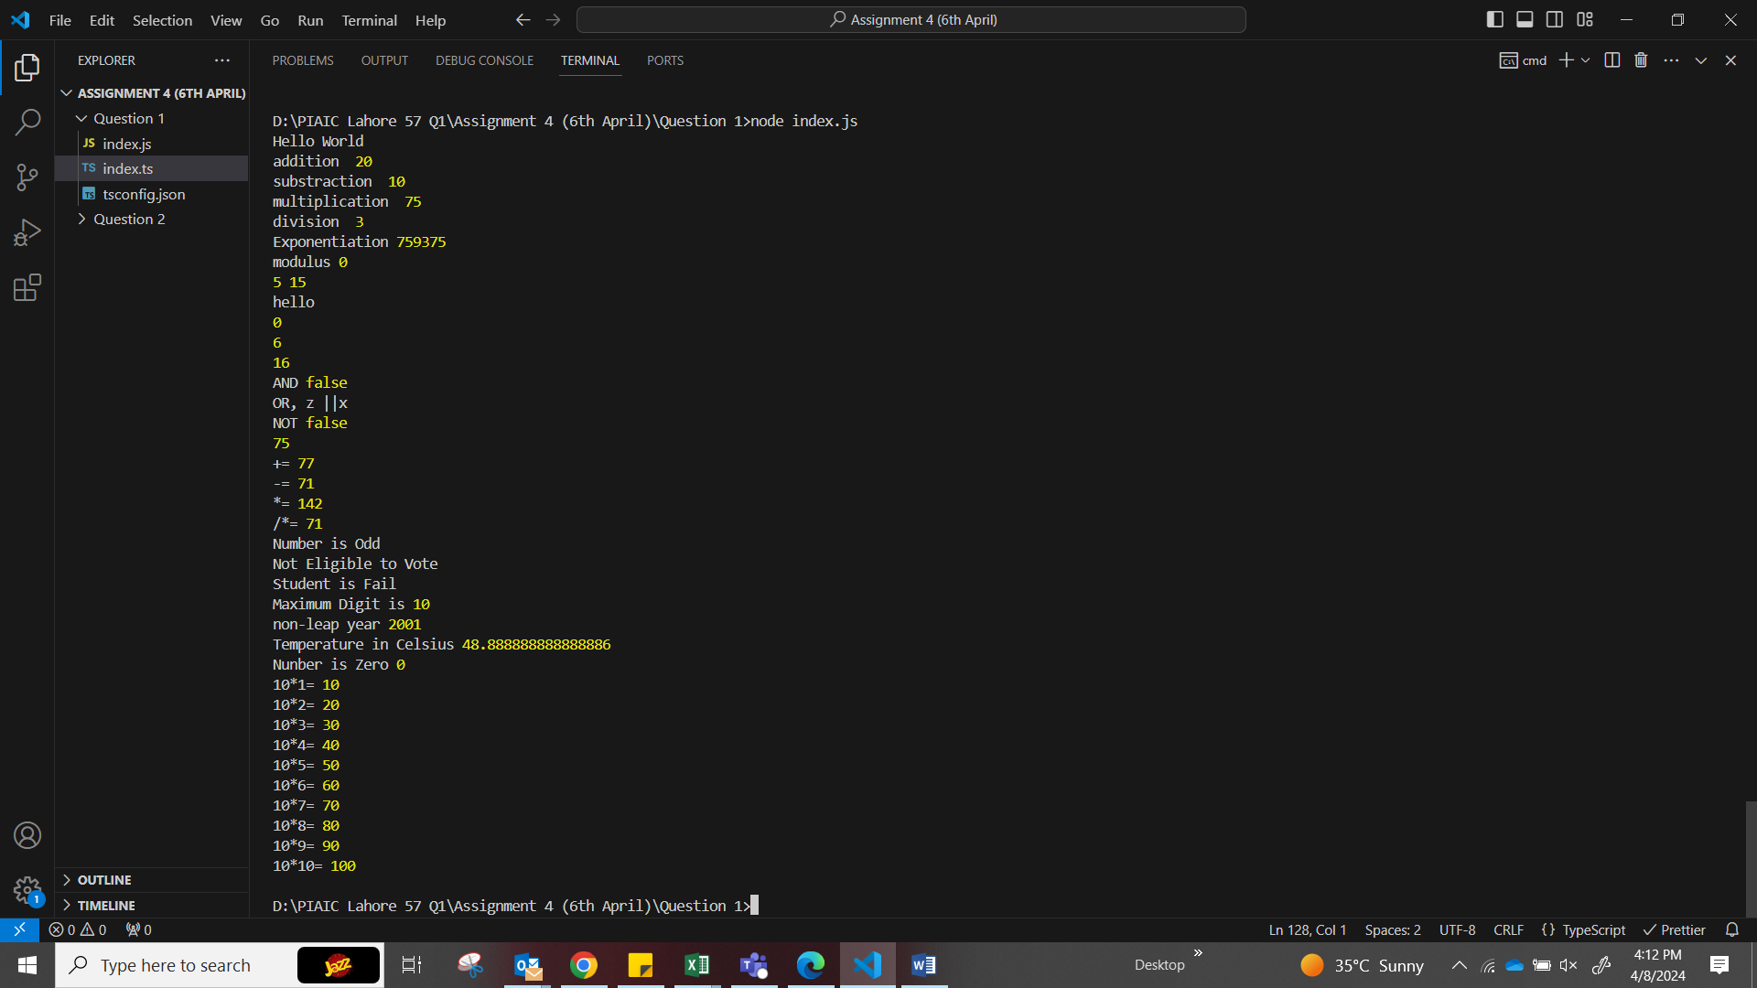

// Instructions: Declare a variable named greeting with the string value "Hello, World!" and print it.

let greeting = "Hello World";

console.log(greeting);

//Instructions: Define two variables with integer values and calculate their sum, difference, product, and quotient.

let num1 = 15;

let num2 = 5;

console.log("addition ", num1 + num2);

console.log("substraction ", num1 - num2);

console.log("multiplication ", num1 * num2);

console.log("division ", num1 / num2);

console.log("Exponentiation", num1 ** num2);

console.log("modulus", num1 % num2);

//Instructions: Swap the values of two variables without using a third variable.

[num1, num2] = [num2, num1];

console.log(num1, num2);

//Instructions: This applies to TypeScript. Create a string variable and try changing its type.

let message: string = "hello";

/*message = 10;

//Type 'number' is not assignable to type 'string'.ts(2322)*/

console.log(message);

//Instructions: Use the modulus operator to find the remainder of two numbers.

let num3 = 50;

let num4 = 25;

console.log(num3 % num4);

//Instructions: Increment a variable's value by 1 using two different methods.

let counter = 5;

counter++;

console.log(counter);

counter += 10;

console.log(counter);

//Instructions: Given three boolean variables, write expressions for AND, OR, and NOT gates.

let z: boolean = true;

let x: boolean = false;

let xy: boolean = true;

console.log("AND", z && x);

console.log("OR, z ||x");

console.log("NOT", !xy);

//Instructions: Show examples of using compound assignment operators.

let R = 75;

console.log(R);

R += 2;

console.log("+=", R);

R -= 6;

console.log("-=", R);

R *= 2;

console.log("*=", R);

R /= 2;

console.log("/*=", R);

//Instructions: Write a program to check if a number is even or odd.

let q = 15;

if (q % 2 == 0) {

  console.log("Number in Even");

} else {

  console.log("Number is Odd");

}

//Instructions: Check if a person is eligible to vote.

let age = 17;

if (age >= 18) {

  console.log("Eligible to Vote");

} else {

  console.log("Not Eligible to Vote");

}

//Instructions: Assign a grade based on a numerical score.

let student = 32;

if (student >= 85 && student <= 100) {

  console.log("Student achieved A grade");

} else if (student >= 80 && student <= 84) {

  console.log("Studend achieved B grade");

} else if (student >= 70 && student <= 79) {

  console.log("Student achieved C grade");

} else if (student >= 60 && student <= 69) {

  console.log("Student achieved D grade");

} else if (student >= 33 && student <= 59) {

  console.log("Student achieved E grade");

} else if (student >= 1 && student <= 32) {

  console.log("Student is Fail");

} else {

  console.log("Invalid Marks, Please Enter correct Marks");

}

//Instructions: Find the maximum of three numbers.

let a1 = 6;

let b2 = 8;

let c2 = 10;

let maximum = Math.max(a1, b2, c2);

console.log("Maximum Digit is", maximum);

//Instructions: Check if a given year is a leap year.

let leap_year = 2001;

if (leap_year % 4 == 0) {

  console.log("It's Leap Year", leap_year);

} else {

  console.log("non-leap year", leap_year);

}

//Instructions: Write a program that converts temperature from Fahrenheit to Celsius.

let Fahrenheit = 120;

let celsius = ((Fahrenheit - 32) * 5) / 9;

console.log("Temperature in Celsius", celsius);

//Instructions: Check if a number is positive, negative, or zero.

let number1 = 0;

if (number1 > 0) {

  console.log("Number is Positive", number1);

} else if (number1 < 0) {

  console.log("Number is Negitive", number1);

} else {

  console.log("Nunber is Zero", number1);

}

//Instructions: Write a program that prints the multiplication table of a given number up to 10.

let table_10 =10

console.log("10*1=",table_10*1)

console.log("10*2=",table_10*2)

console.log("10*3=",table_10*3)

console.log("10*4=",table_10*4)

console.log("10*5=",table_10*5)

console.log("10*6=",table_10*6)

console.log("10*7=",table_10*7)

console.log("10*8=",table_10*8)

console.log("10*9=",table_10*9)

console.log("10*10=",table_10*10)